Tasks on Terraform-02
1) Execute all the templates shown in video.

Life Cycle Rules:
1) create_before_destroy:
usually when we make any changes and execute terraform apply, there will be first destroying then creating is the terraform behaviour, because it is immutable.
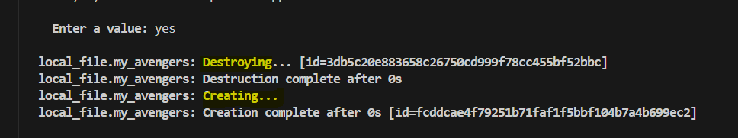

If we use create_before_destroy life cycle then creation will be done first then destruction will be done after making changes in the template.
So, we are adding this policy to our template.
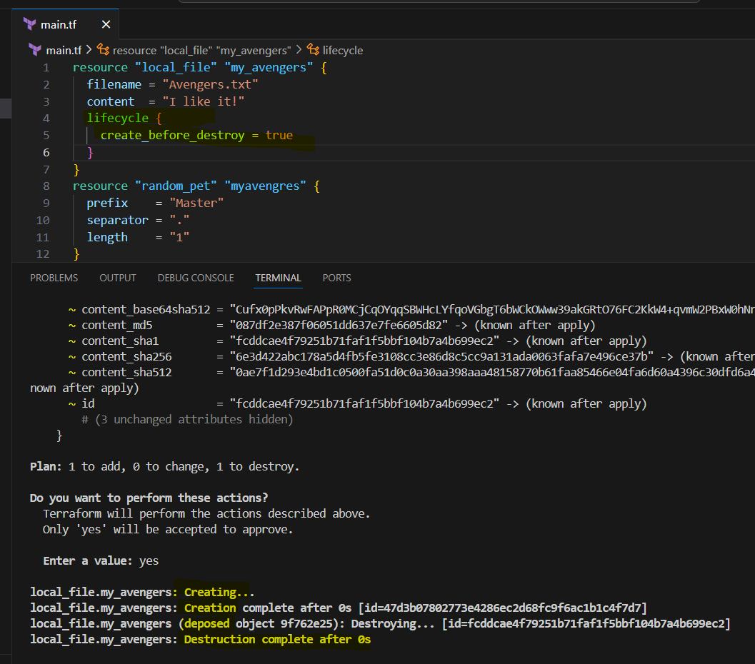
We can see how the policy works.
2) prevent_destroy:
usually when we make any changes and execute terraform apply, there will be destroying and creating in the output.


If we use prevent_destroy life cycle then creation will be done and there will be no destruction done after making changes in the template.
So, we are adding this policy to our template.
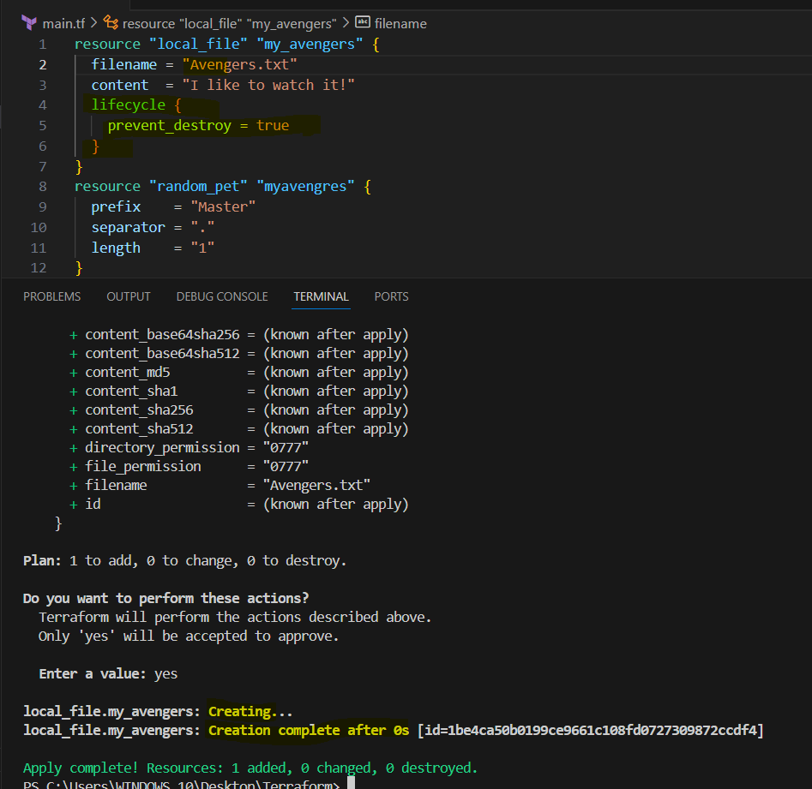
We can see how the policy works.
3) ignore_changes:
usually when we make any changes and execute terraform apply, there will be destroying and creating in the output.


If we use ignore_changes life cycle then there will be no creation or destruction even after making changes in the template.

So, we are adding this policy to our template.
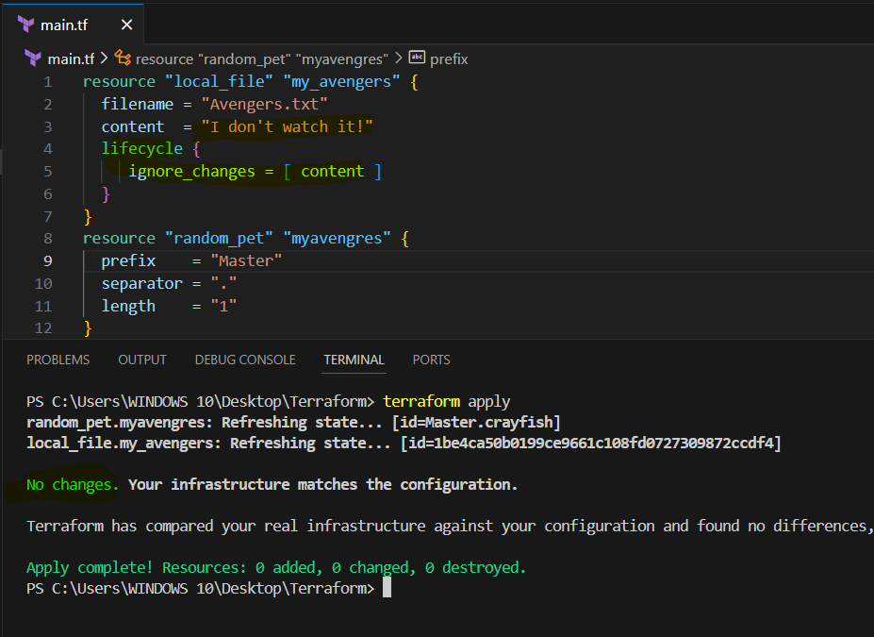
We can see how the policy works.

Variables:

First, we need to create a variables.tf file to add variables in that.
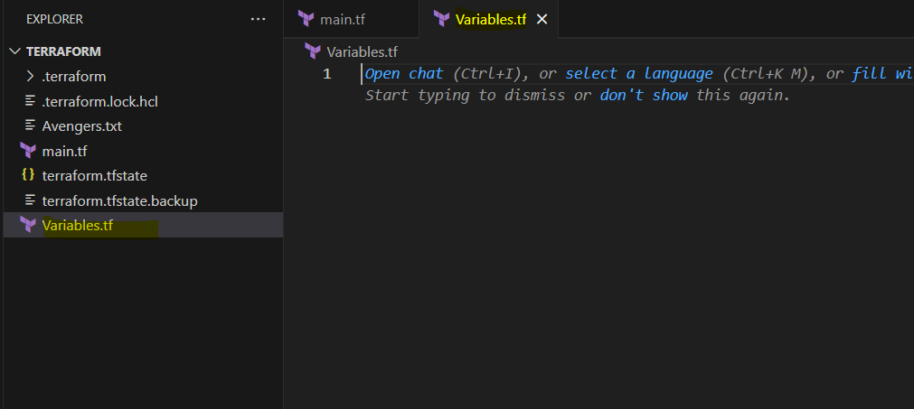

1) Creating a template by using variables.tf file
Main.tf
resource "local_file" "devops" {
filename = var.filename
content = var.content
}
resource "random_pet" "devops" {
prefix = var.prefix
separator = "."
length = var.length
}

Varaibale.tf
variable "filename" {
default = "devops.txt"
type = string
}
variable "content" {
default = "This is terraform task"
type = string
}
variable "prefix" {
default = "Course"
type = string
}
variable "length" {
default = "2"
type = number
}

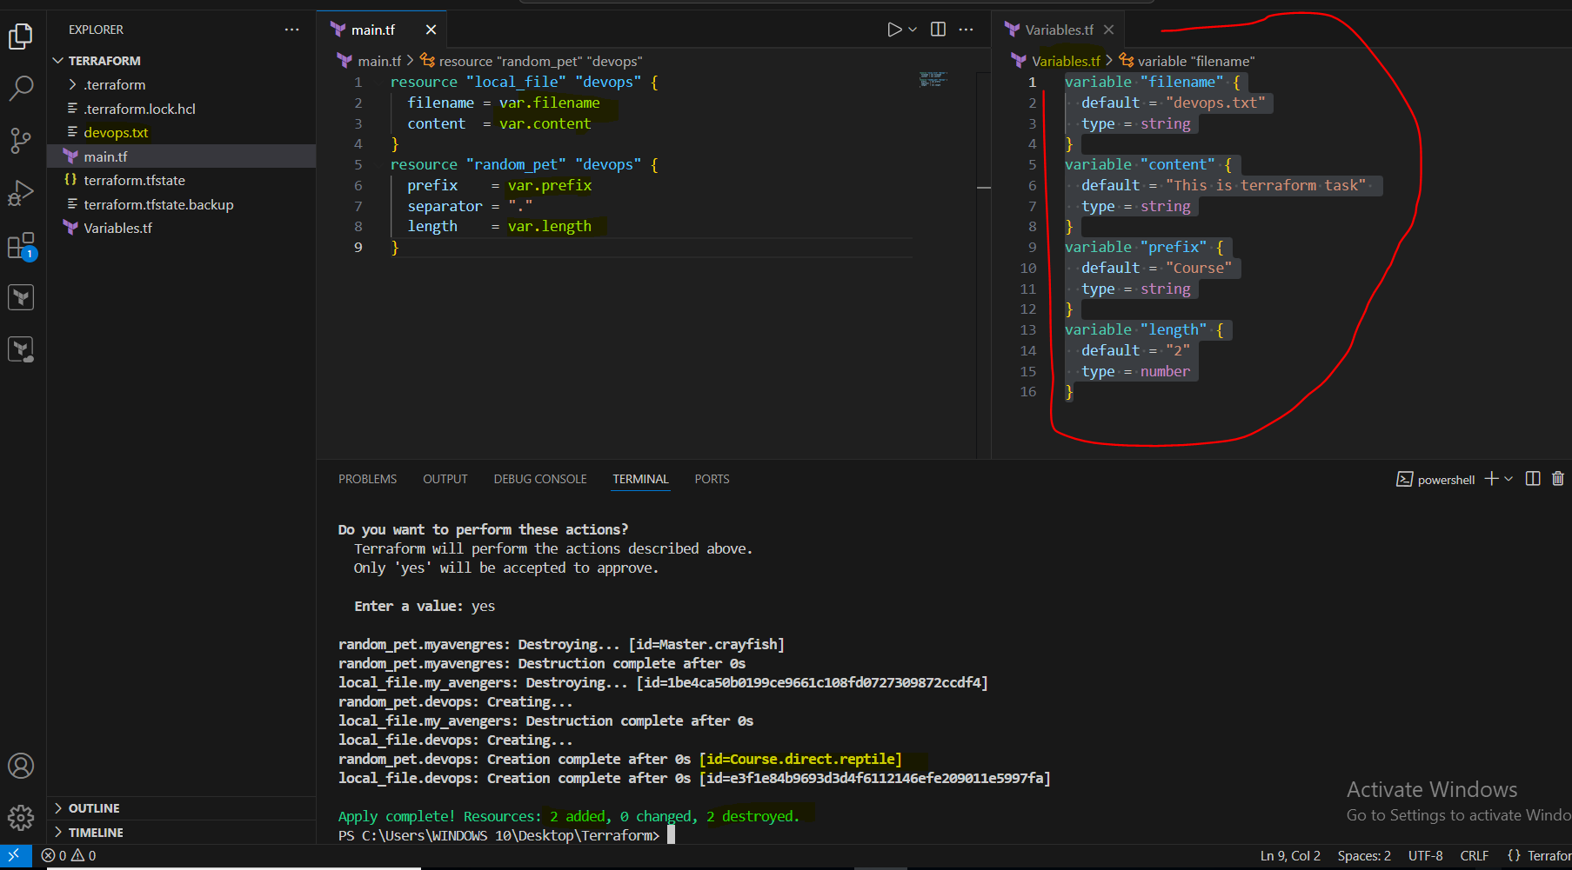

2) By using Interactive mode.
We need to define empty variables in variable.tf file, then terraform apply and define values for those variables as shown below.
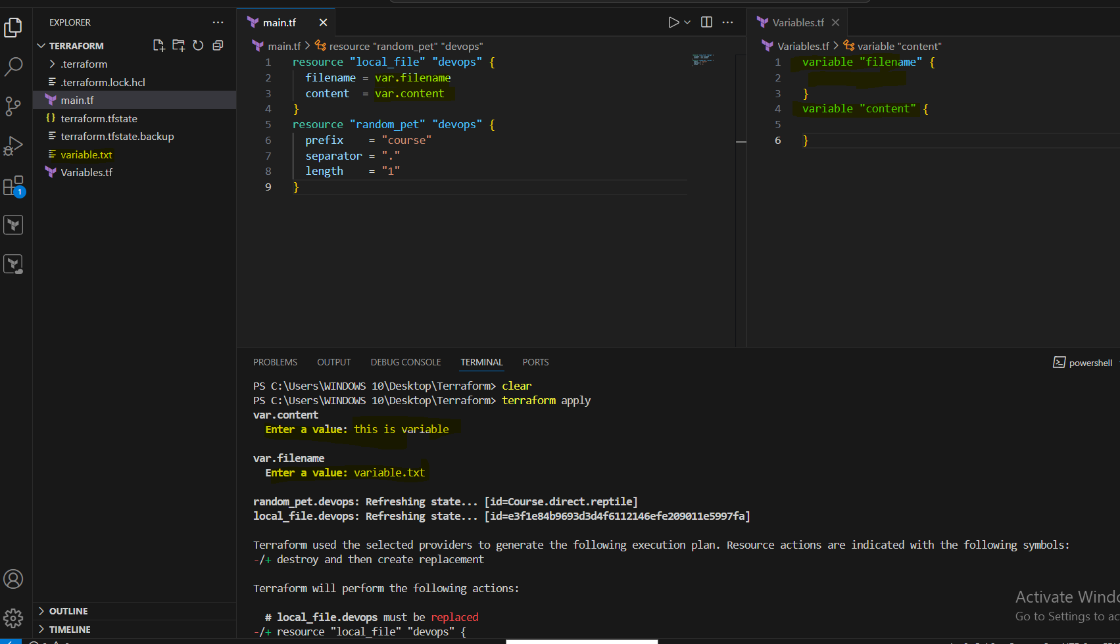

3) Command Line Flags.

We need to define empty variables in variable.tf file, then we need to add command with -var defining the variable’s as shown below.

terraform apply -var "filename=command.txt" -var "content=command line flags"
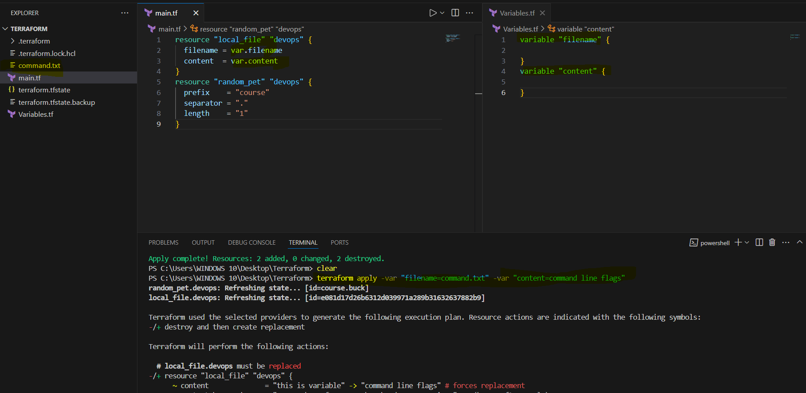

2) Integrate terraform in jenkins using Terraform plugin.

We need to install Terraform plug in our Jenkins.
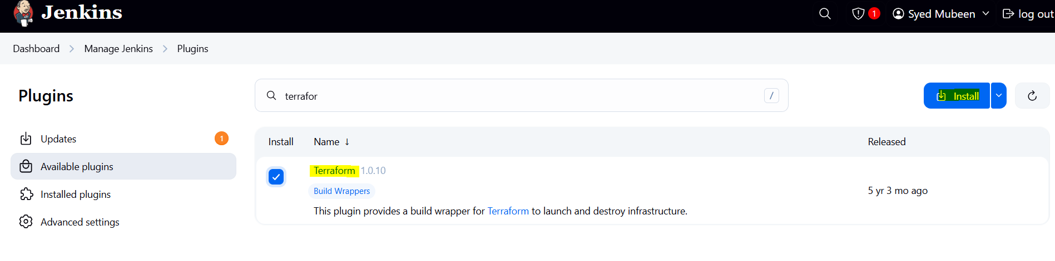

Need to configure Terraform in tools.
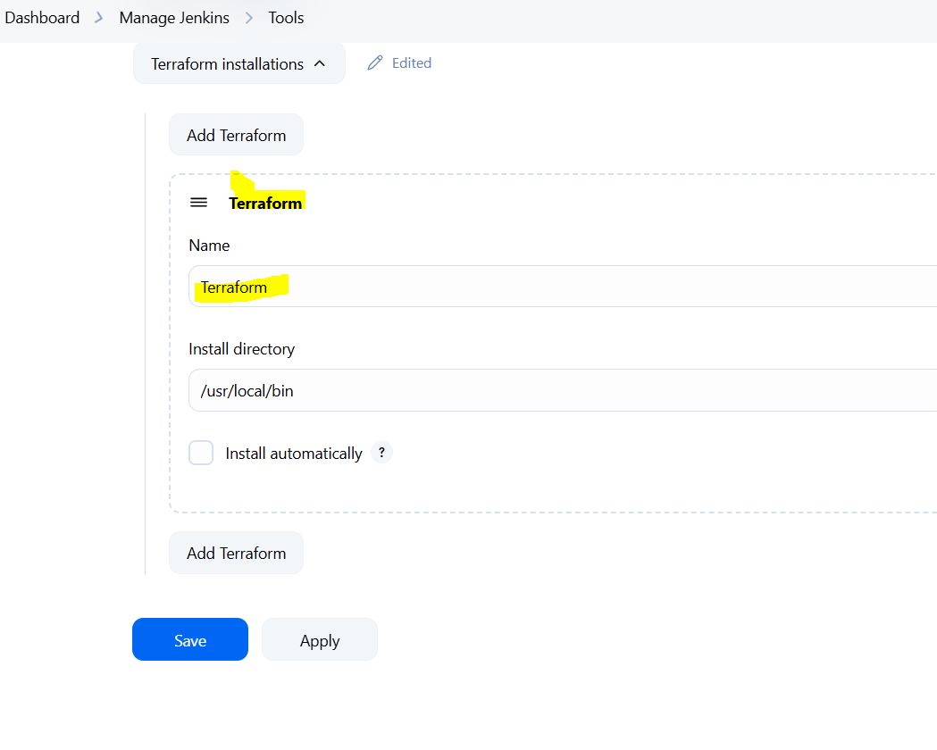

Template in main.tf of the git repo.

resource "local_file" "devops" {
filename = "devops.txt"
content = "terraform task"
}
resource "random_pet" "devops" {
prefix = "course"
separator = "."
length = "1"
}

Create a job with name Terraform.
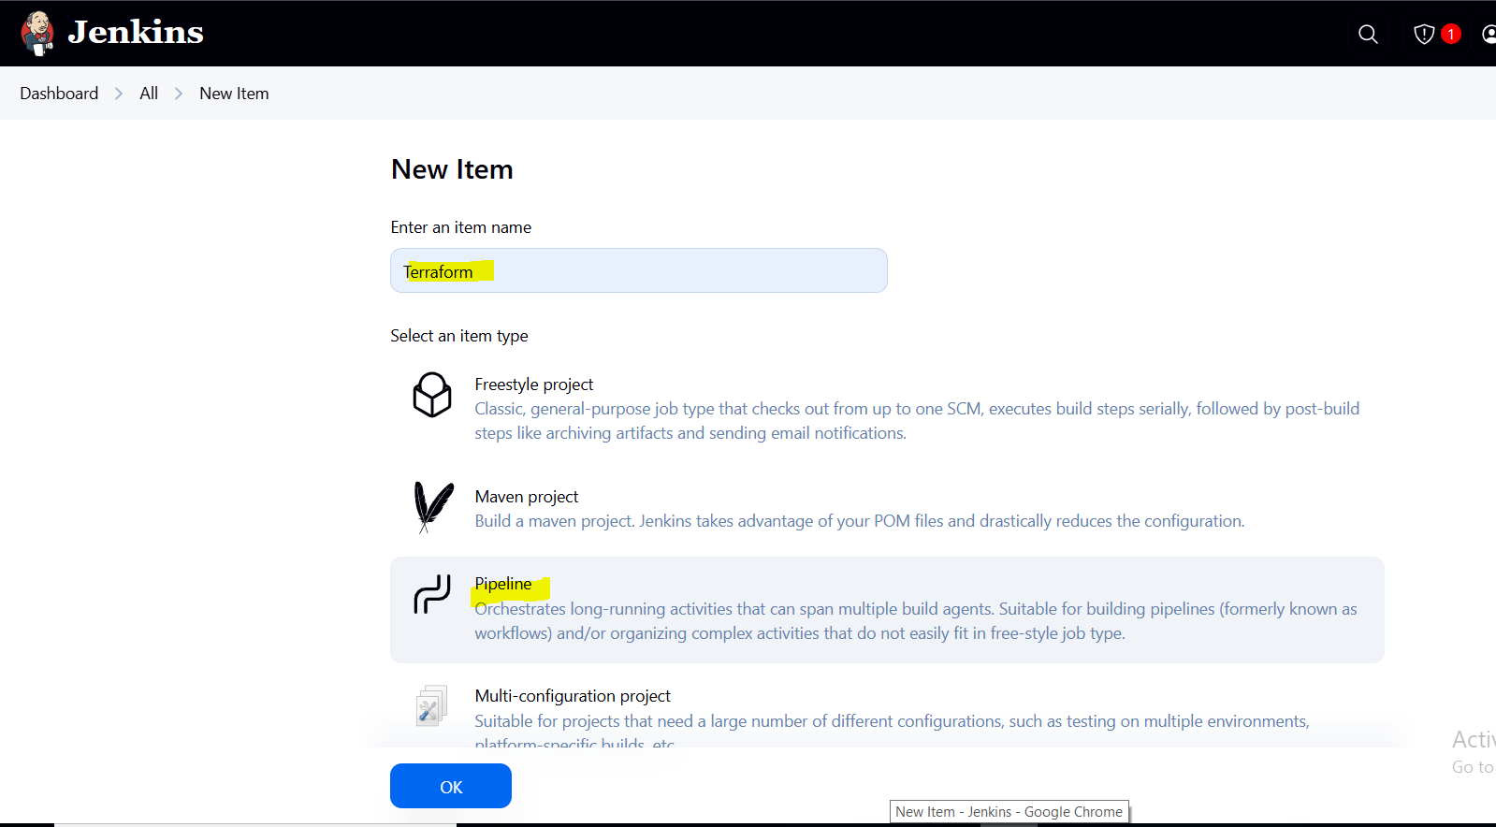
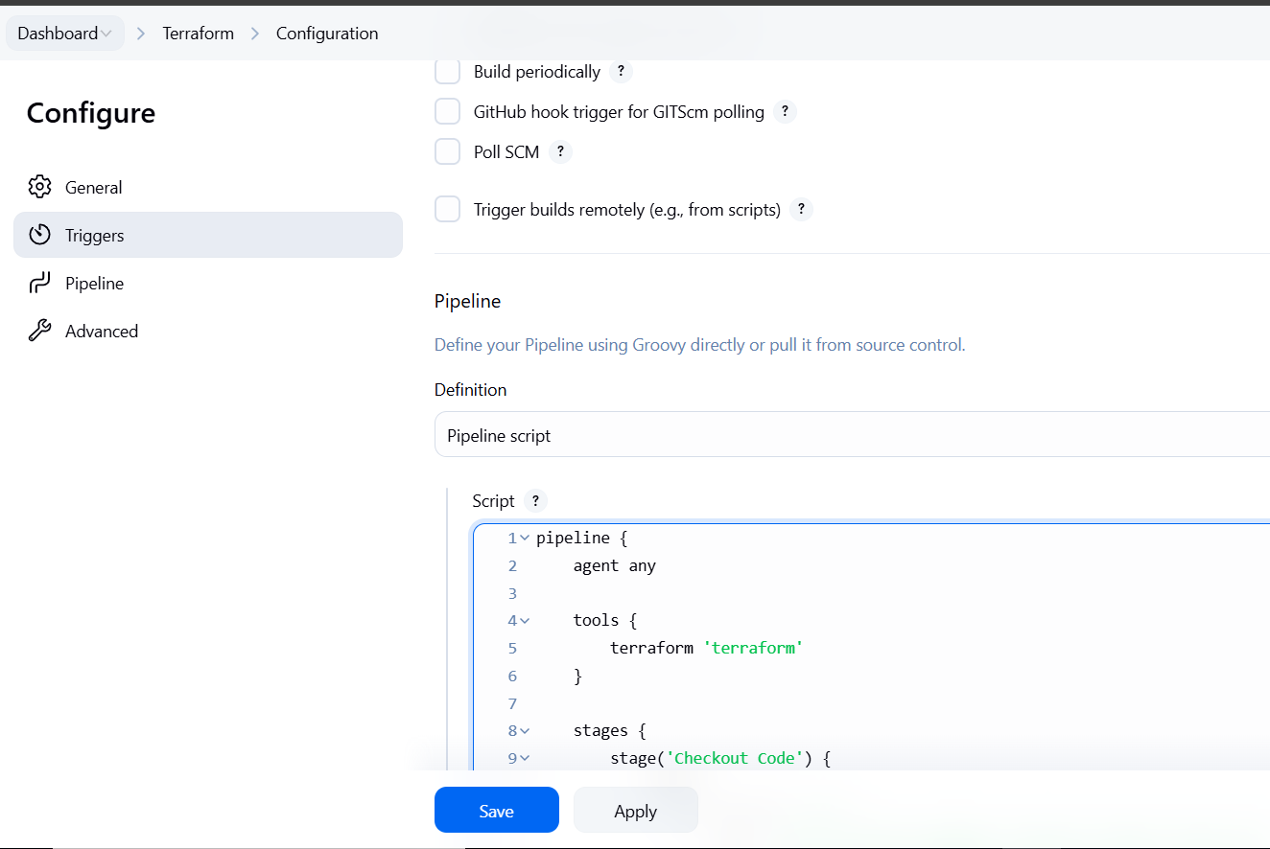

Pipeline used:
pipeline {
agent any

tools {
terraform 'Terraform'
}

stages {
stage('Checkout Code') {
steps {
git branch: 'main',
url: 'https://github.com/mubeen-hub78/terraform-jenkins.git'
}
}
stage('Terraform Init') {
steps {
sh 'terraform init'
}
}
stage('Terraform Apply') {
steps {
sh 'terraform apply -auto-approve'
}
}
}
}

Now run the job.
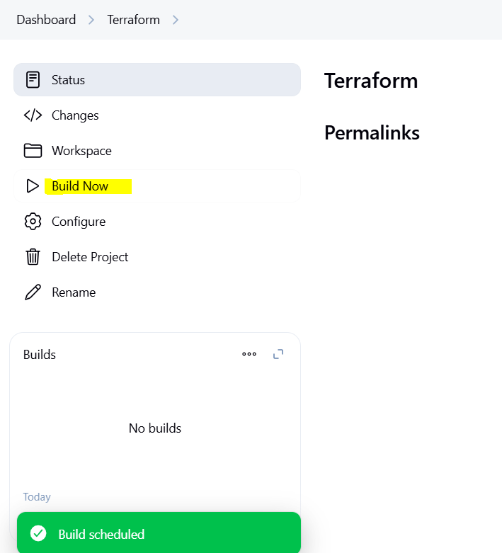

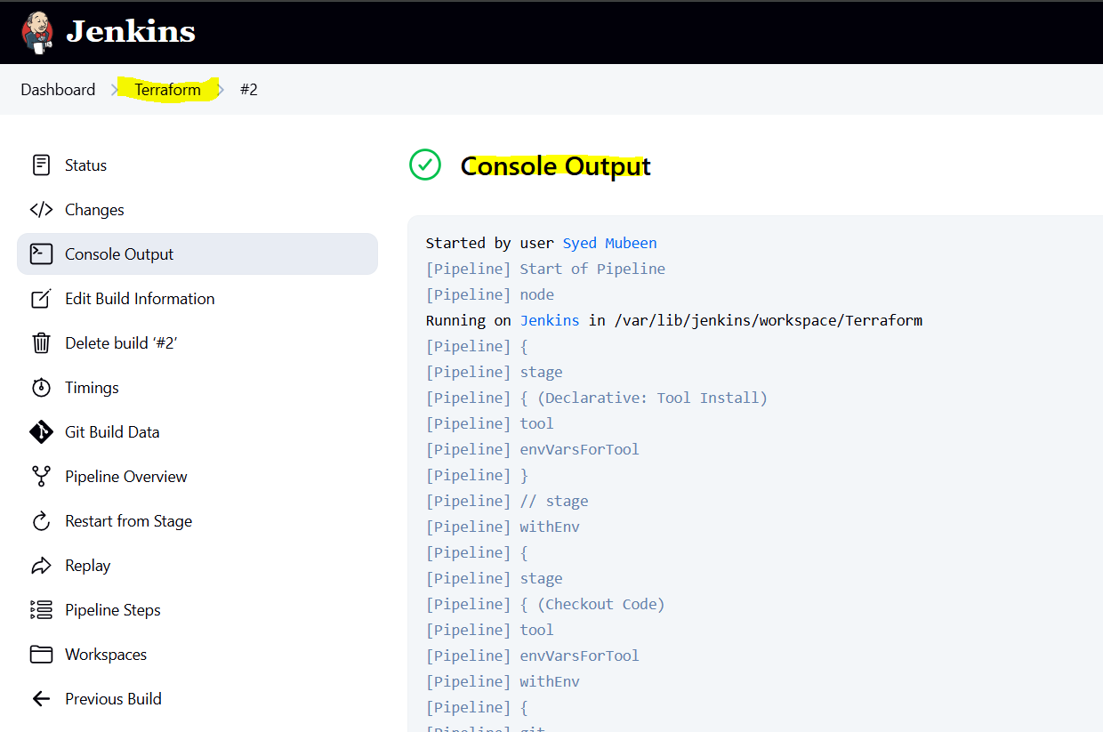

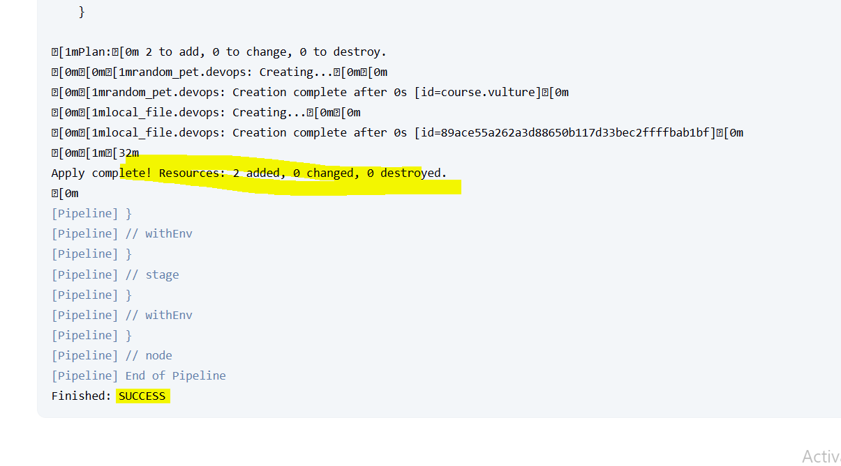

THE-END

